**Jira software**

|  |  |
| --- | --- |
| Date | 15 November 2022 |
| Team ID | PNT2022TMID17749 |
| Project Name | A novel method for handwritten digit recognition system. |
| Maximum Marks | 4 Marks |

RoadMap:

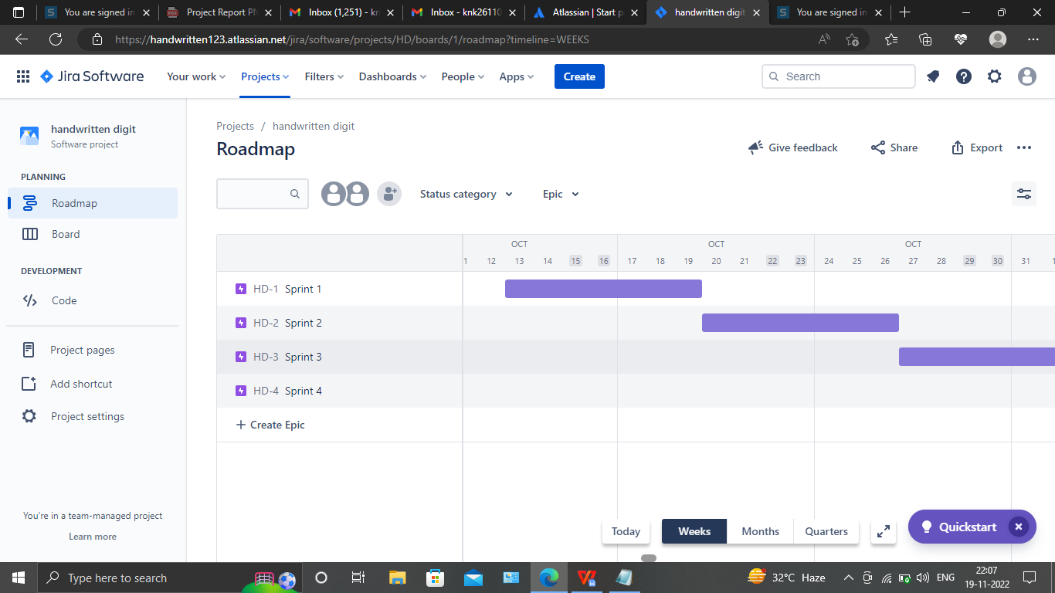

Backlog:

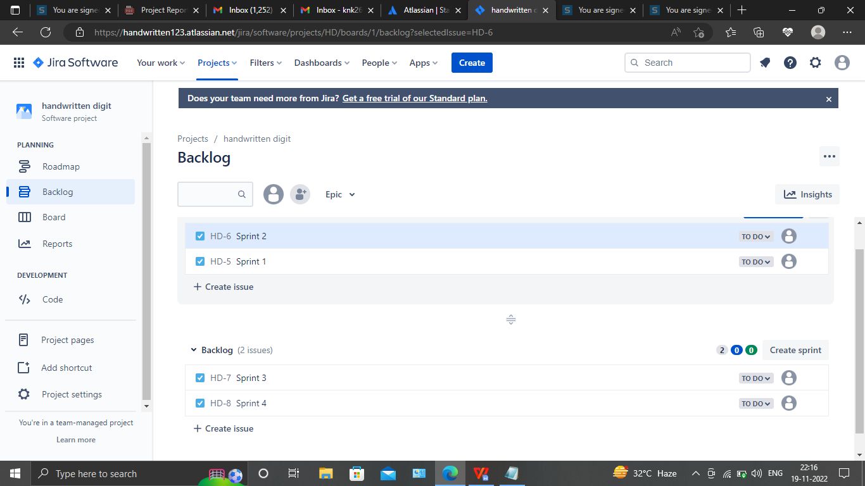

Board:

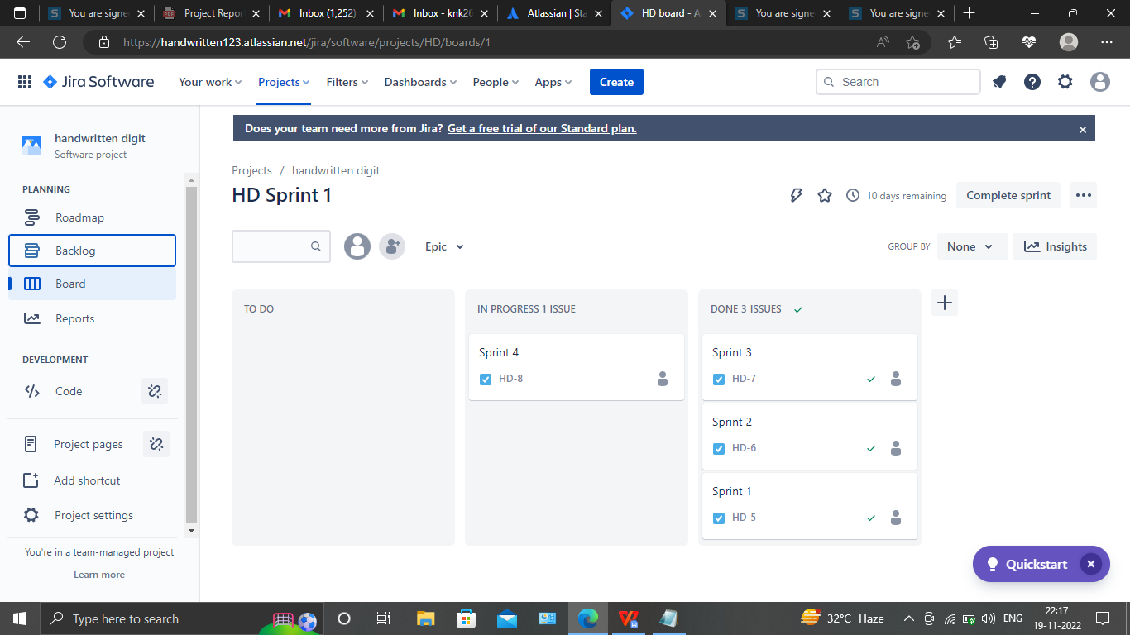

Burnup report

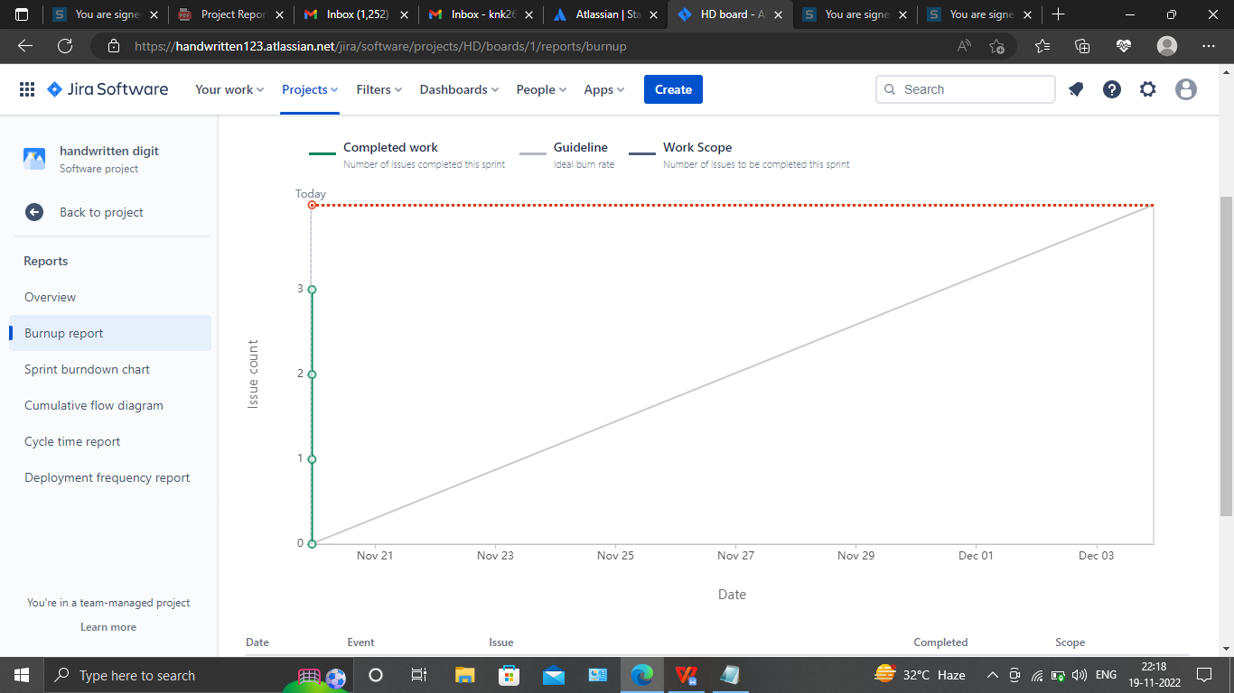

JIRA link:

https://handwritten123.atlassian.net/jira/software/projects/HD/boards/1/reports/burndown

Sprint burndown chart:

